CURRICULUM VITAE
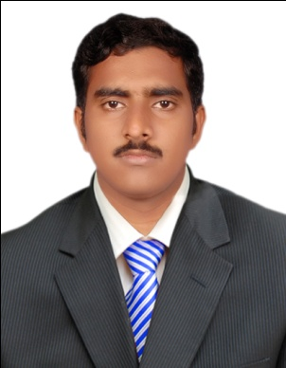
K.Mohamed Jafer Khan
Gate Gate Building,
C Block,
Burj 2000 building oppisite-Rolla,
Sharjah.
jaferkhan50@gmail.com
Cell: +971522110670

OBJECTIVE:

To secure a challenging position where I can effectively contribute my skills as Software Professional, possessing competent Technical Skills.

EDUCATION PROFILE:

B.E (EEE) | National College of Engineering | Anna University | 2008-2012
H.S.C | Little Flower Matriculation School | Matric Board  of Tamilnadu | 2006-2008
X CLASS  (S.S.L.C) | Chitra Matriculation School | Matric Board  of Tamilnadu | 2005-2006

TECHNICAL PROFILE:

Operating System : Windows-XP
Office Suite : MS.Office-2003, 2007.
Applications : Foxpro,Tally

SOFTWARE SKILLS:

➢ AUTOCAD
➢ E-CAD 

ACHIEVEMENTS:

Undergone training at Thoothukudi Thermal Power station(Tamilnadu)

EXPERIENCE:

- One year experiencene in Trainee Electrical Engineer in ASHA ELECTRICALS(MADRAS)P.LTD (10th August 2012 to 03rd October 2013).

- Worked as Maintenance supervisor in JK WIND ENERGY systems in NAGERCOIL, tamilnadu . (03rd January 2014 to 11th November 2016).

- Worked as a Service advisor in DERIK MOTORS in Tirunelveli .(5th March 2017 to 30th September 2017).

Strengths

- ➢Good at team work.
- ➢Capability of working hard.
- ➢Quick learner

PROJECT :

Project Title : THREE PHASE PWM RECTIFIER USING DC CURRENT SENSOR

Softwares used : MATLAB
ATMEL Controller : AT89C51
Role : Team leader
Team Size : 4
Duration : 3 Month
Rectifier : PWM Rectifier

DESCRIPTION :
The project presents a new current control method for Pulse Width Modulation Rectifier with active power factor correction.But the conventional method requires atleast two input phase current.The proposed method solves the problems by using only DC_rail current acts as a feedback signal.DC-rail current can be easily sensed by shunt resistor and the sensed signal can be directly used by control circuit without isolation or any level shifting.

Roles and Responsibilities

- Supported team members in understanding the project and the requirement.
- Prepared documentation for the project.

PASSPORT DETAILS:

Passport Number : K7500142
Validity : 11-9-2012 to 10-9-2022

DRIVING LICENSE DETAILS:

Driving License Number : TN7220080006233
Date of Issue : 31/07/2008
Valid up to : 30/07/2028

PERSONAL PROFILE:

Full Name : K.MOHAMED JAFER KHAN
Father Name : S.U.KAJA SHAHUL HAMEED
Date of Birth : 25/02/1990
Sex : male
Martial Status : Single
Nationality : Indian-Muslim
Known Languages : Tamil and English
Permanent Address : 71/72 Azad Street,
Cheranmahadevi-627414
Tirunelveli district.
Tamilnadu.India.
Contact No. : +971522110670
Whatsapp no : +919025791977

(K.MOHAMED JAFER KHAN)

